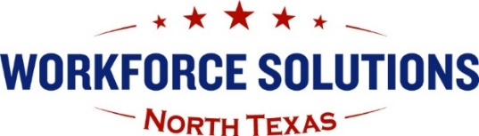
Workforce Solutions North Texas Board Administration
1501 Midwestern Parkway, Suite 101
Wichita Falls, TX 76302
Phone: 940-767-1432 | Fax: 940-322-2683
Email: NTXBoard@ntxworksolutions.org
Website: www.ntxworksolutions.org

Youth Advisory Group Meeting

Members of the Youth Advisory Group of the Workforce Solutions North Texas (WSNT) Workforce Development Board will meet at 10:30a.m. on Thursday, August 26 via Zoom.

Due to the ongoing health concerns with the COVID-19 pandemic, we will be observing social distancing. In-person attendance at the WSNT Board Office Conference Room at 1501 Midwestern Parkway, Suite 101 in Wichita Falls, TX, will be limited to staff and board members. You are encouraged to join the meeting virtually via Zoom. Please let us know in advance if you will attend in person due to limited meeting space. We appreciate your patience and understanding in this matter.

Brenda Roland is inviting you to a scheduled Zoom meeting.

Topic: Youth Advisory Group Meeting - August
Time: Aug 26, 2021, 10:30 AM Central Time (US and Canada)

Register in advance for this Zoom meeting:

After registering, you will receive a confirmation email containing information about joining the Zoom meeting.

Join Zoom Meeting

https://us06web.zoom.us/j/87933073547?pwd=Z0prYXdFVDRTTC9CVnQzT3JOTHVwdz09

Meeting ID: 879 3307 3547
Passcode: 420872

Agenda

- Call to order – Mr. Billy Clark, Chair

  - Recording notification
  - Introductions
  - Review agenda
  - Discuss additional agenda items

- Discuss topics that were not completed in a previous meeting.

- Announcement/New topics for this month’s meeting

- New School Year!

- Update: Summer Earn and Learn (SEAL)

- Youth Career Expo – Tuesday, September 28, 2021

- Transition Fair – Wednesday, October 13, 2021

- Other

- Information to include in Board Report

- Other Discussion

- Next Meeting Date –

  - Thursday, October 28, 2021, at 10:30 a.m.

- Adjournment

The Vision of the Youth Advisory Group to Workforce Solutions North Texas, the North Texas Workforce Development Board, is to create a community whose youth lead in using academics, knowledge, and technology to improve the local workforce.

The Mission of the Youth Advisory Group is to bring together all youth programs in the area under one comprehensive service umbrella including year-round in-school, out-of-school, and other youth initiatives to assist youth and young adults with life skills, training, and opportunities necessary to gain success in post-
secondary education and in the workforce as they strive to become productive citizens.

