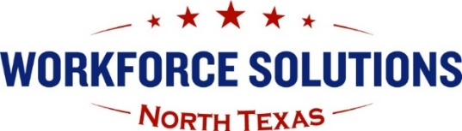
Workforce Solutions North Texas Board Administration
1501 Midwestern Parkway, Suite 101
Wichita Falls, TX 76302
Phone: 940-767-1432 | Fax: 940-322-2683
Email: NTXBoard@ntxworksolutions.org
Website: www.ntxworksolutions.org

Youth Advisory Group Meeting

Members of the Youth Advisory Group of the Workforce Solutions North Texas (WSNT) Workforce Development Board will meet at 10:30a.m. on Thursday, November 4 via Zoom.

Due to the ongoing health concerns with the COVID-19 pandemic, we will be observing social distancing. In-person attendance at the WSNT Board Office Conference Room at 1501 Midwestern Parkway, Suite 101 in Wichita Falls, TX, will be limited to staff and board members. You are encouraged to join the meeting virtually via Zoom. Please let us know in advance if you will attend in person due to limited meeting space. We appreciate your patience and understanding in this matter.

Brenda Roland is inviting you to a scheduled Zoom meeting.

Topic: Youth Advisory Group Meeting - October
Time: November 4, 2021, 10:30 AM Central Time (US and Canada)

Join Zoom Meeting

https://us06web.zoom.us/j/81773723772?pwd=elByUEp2aE1hY0hWb3hJM3VIdGV0QT09

Meeting ID: 817 7372 3772
Passcode: Advisory

Agenda

- Call to order – Mr. Billy Clark, Chair

  - Recording notification
  - Introductions
  - Review agenda
  - Discuss additional agenda items

- Discuss topics that were not completed in a previous meeting.
- Announcement/New topics for this month’s meeting

- Youth Career Specialist high school outreach efforts.

- Jobs Y’all Youth Career Expo results - September 28, 2021

- Transition Fair – Wednesday, October 13, 2021

- Encore Transition Fair – Wednesday, October 27, 2021

- 24th Annual Texas Workforce Conference scheduled for November 17 – 19, 2021, at the Marriott Marquis Houston, in Houston, Texas.

- Other

- Information to include in Board Report

- Other Discussion

- Next Meeting Date –

  - Thursday, December 9, 2021, at 10:30 a.m.

- Adjournment

The Vision of the Youth Advisory Group to Workforce Solutions North Texas, the North Texas Workforce Development Board, is to create a community whose youth lead in using academics, knowledge, and technology to improve the local workforce.

The Mission of the Youth Advisory Group is to bring together all youth programs in the area under one comprehensive service umbrella including year-round in-school, out-of-school, and other youth initiatives to assist youth and young adults with life skills, training, and opportunities necessary to gain success in post-
secondary education and in the workforce as they strive to become productive citizens.

Youth Career Specialist high school outreach efforts
- Jobs Y’all Youth Career Expo results

