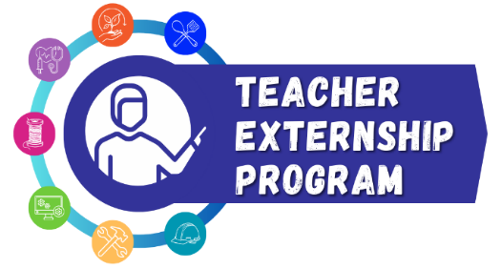


LETTER OF COMMITMENT

The Summer 2026 Teacher Externship program is provided as a no-cost, win-win opportunity for educators and industry. The Texas Workforce Commission (TWC), in partnership with Workforce Solutions North Texas (WSNT), has provided funding to help support skills development for career educators in Texas to create the most effective educational experience for students in career-based learning. I am excited that you have chosen to be a part of this unique opportunity! The only thing that we are asking of you is your commitment to attend, participate, and complete the program requirements within the agreed timeline. That’s it!

Your signature below indicates your commitment to:
(1) Complete all paperwork required by TWC, WSNT, and your host worksite employer;
(2) Attend pre-externship orientation;
(3) Complete 40-hour externship over 2 weeks at assigned host worksite during Summer 2026;
(4) Develop lesson plan based on worksite experience and provide a copy to WSNT;
(5) Deliver lesson plan to students during Fall 2026;
(6) Coordinate a classroom visit by your host worksite or a field trip for students during Fall 2026; and
(7) Complete final report by December 2026.

Once all items are completed, a stipend check for $2,000 and a $500 classroom supplies stipend will be awarded to you. Our office will be in touch to guide you through each step of the process. We are here for encouragement and support as you progress towards your goals!

Educator Signature Date

Administrator Signature Date

For staff use only
Worksite/Employer Name
Industry/Career of Externship
Worksite POC
Orientation Needs
Worksite: Beginning Date:_________ | Ending Date:
Lesson Plan Received (date: ______) | Yes | No (if No, explain: _______________________________)
Classroom/Field Visit (date: ______) | Yes | No (if No, explain: _______________________________)
Final Report Received (date: ______) | Yes | No (if No, explain: _______________________________)

